CPE301 – SPRING 2019

Design Assignment 6

Student Name: John Duriman

Student #: 5002373995

Student Email: duriman@unlv.nevada.edu

Primary Github address: https://github.com/johnduriman/pirahnaplant.git

Directory: pirahnaplant/Design Assignments/DA6/

1. **COMPONENTS LIST AND CONNECTION BLOCK DIAGRAM w/ PINS**

List of Components used:

Atmega328P

Wires

MPU6050

Block diagram with pins used in the Atmega328P

|  |  |
| --- | --- |
| Atmega328P | MPU6050 |
| VCC | VCC |
| Ground | Ground |
| PC4 | SDA |
| PC5 | SCL |
|  |  |

1. **INITIAL/MODIFIED/DEVELOPED CODE OF TASK 1/A**

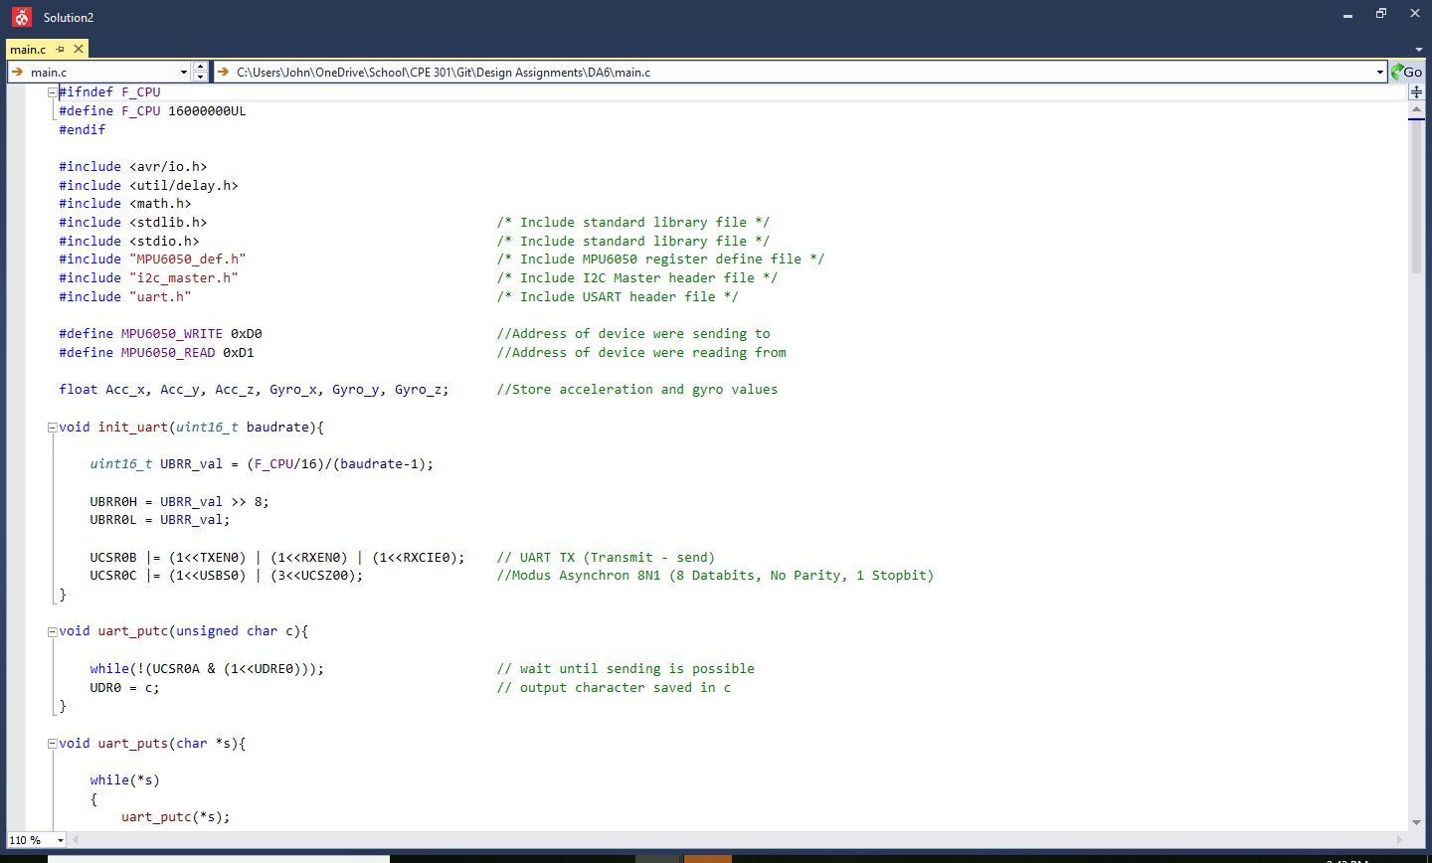

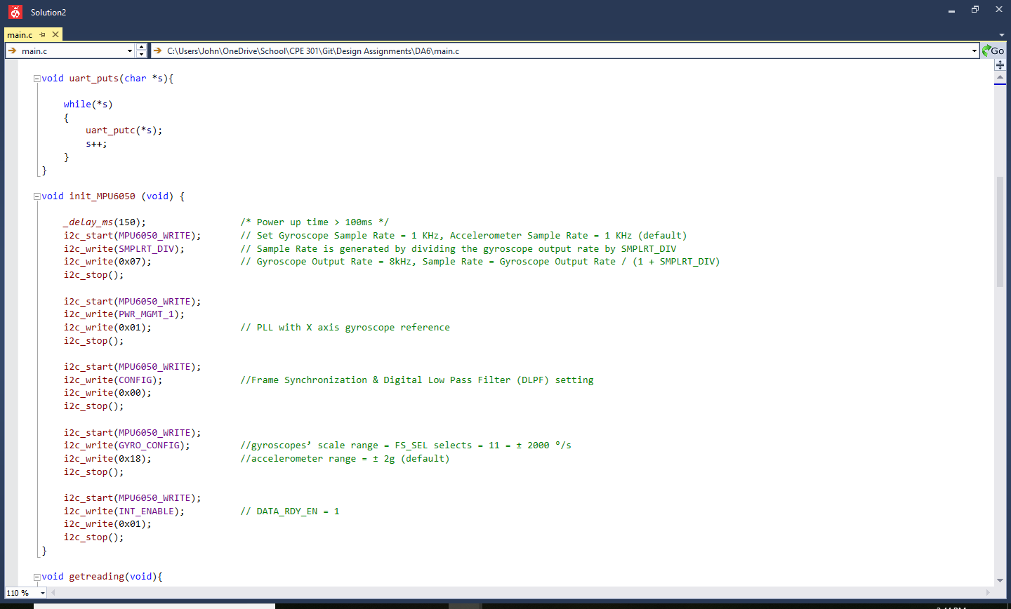

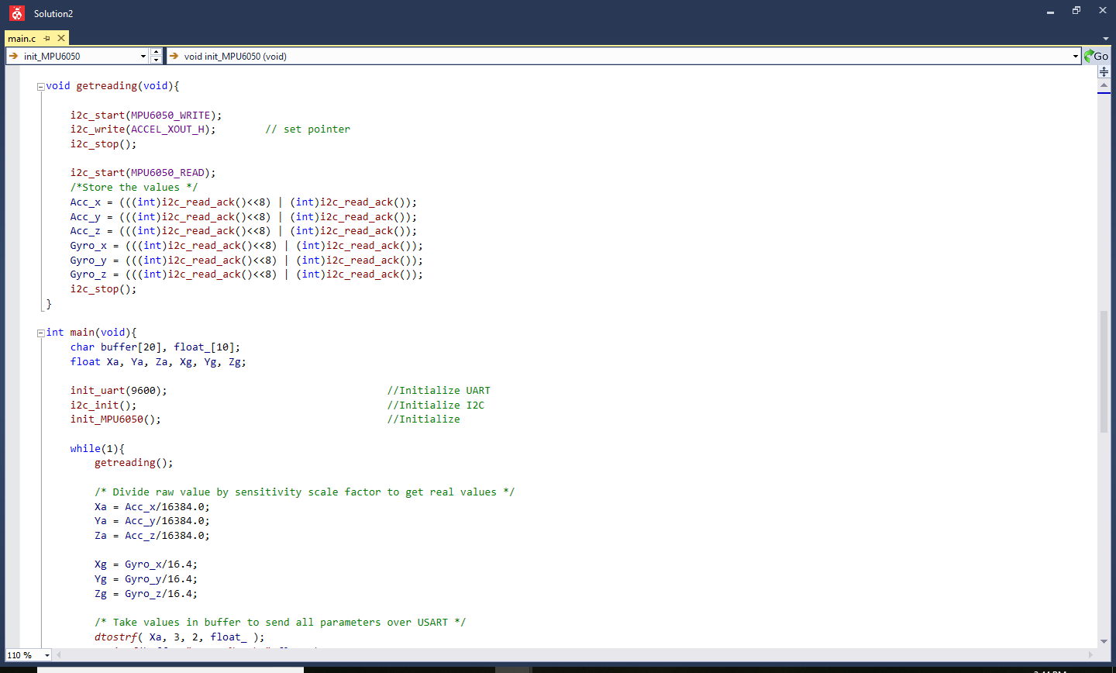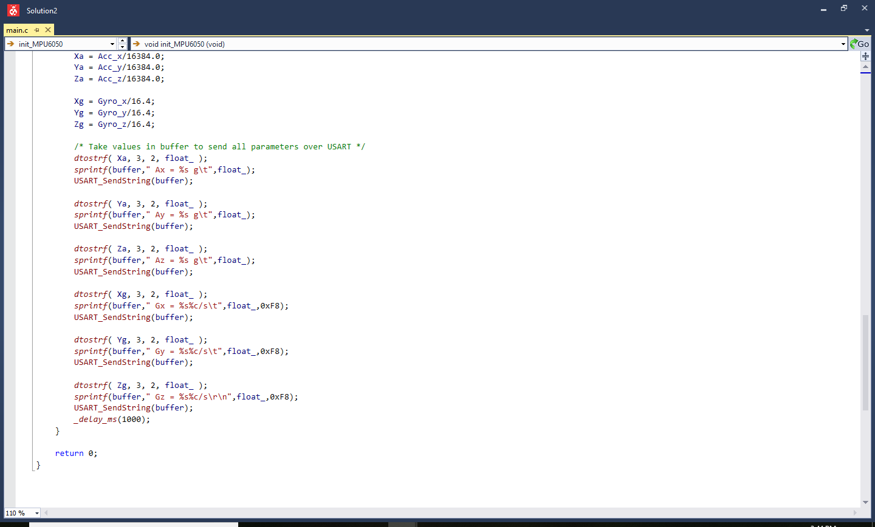

1. **SCREENSHOTS OF EACH TASK OUTPUT (ATMEL STUDIO OUTPUT)**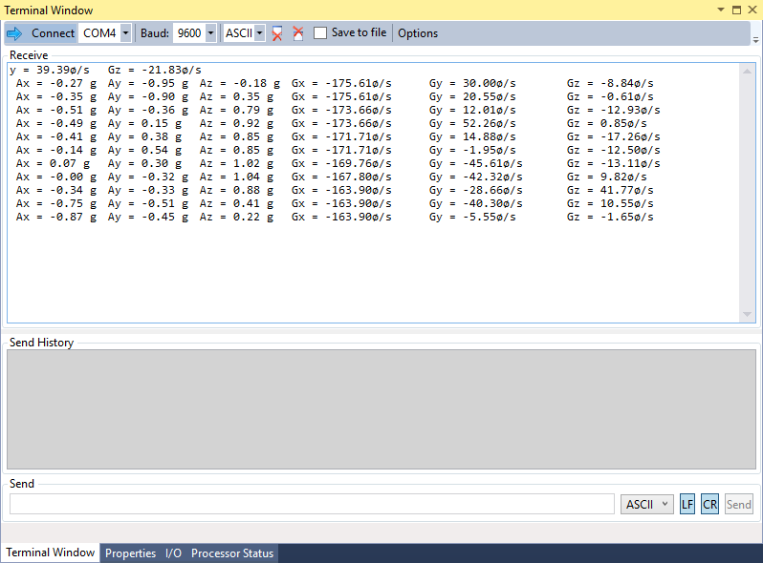
2. **SCREENSHOT OF EACH DEMO (BOARD SETUP)**

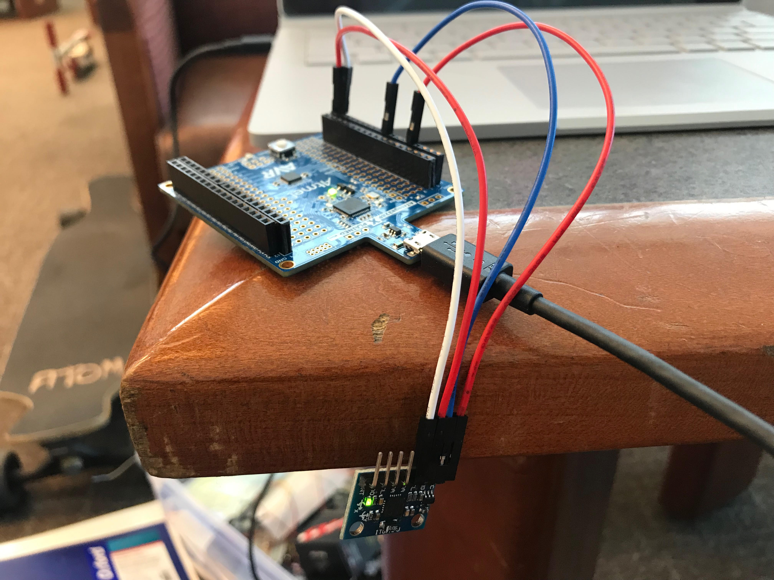

1. **VIDEO LINKS OF EACH DEMO**

N/A

1. **GITHUB LINK OF THIS DA**

pirahnaplant/Design Assignments/DA6/

**Student Academic Misconduct Policy**

<http://studentconduct.unlv.edu/misconduct/policy.html>

“This assignment submission is my own, original work”.

John Duriman